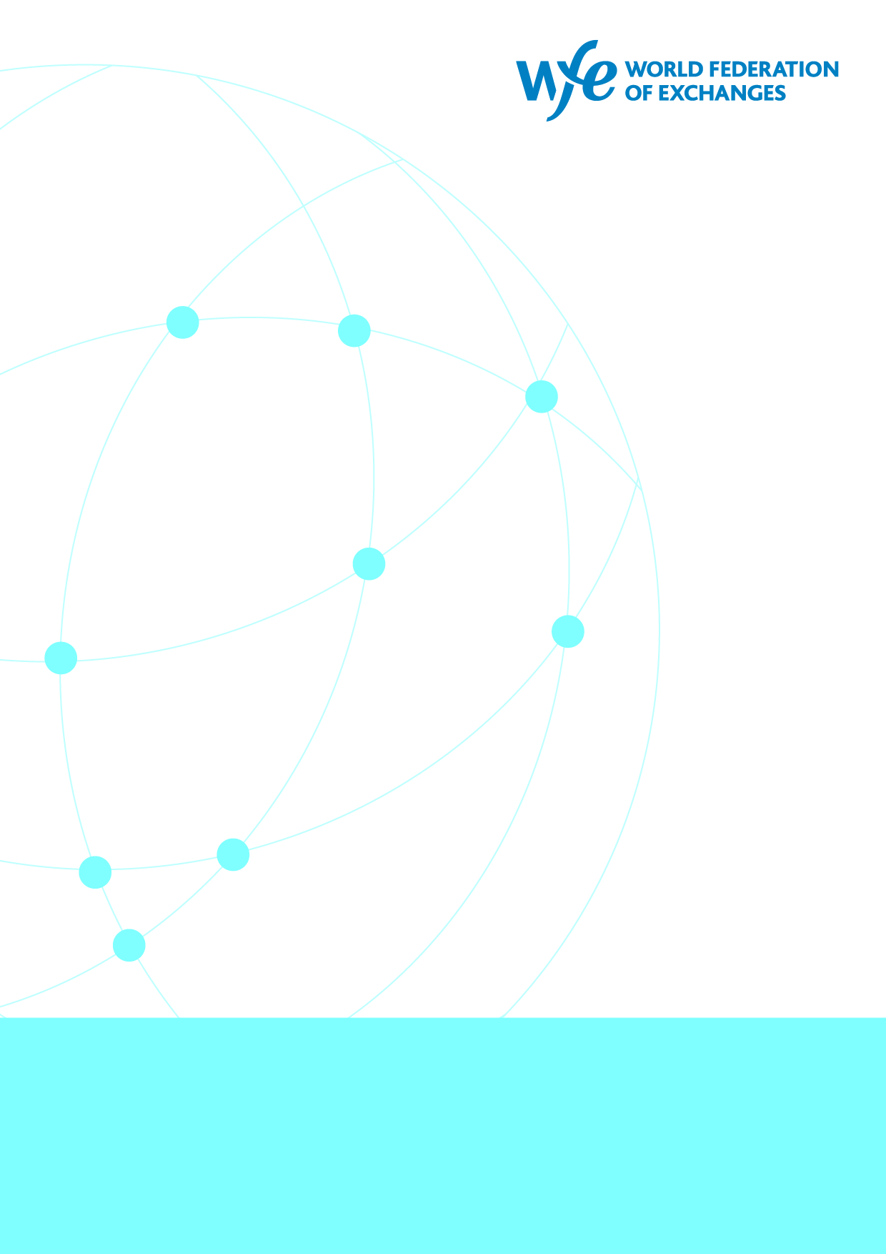
2

The Innovation Advantage in Well-Regulated Markets
21 April 2026

Summary
This paper argues that innovation and investor protection in financial markets are complementary, not competing, goals. Over the past 50 years, equity markets have expanded dramatically in scale, participation, and technological sophistication (driven by innovations such as electronic trading, dematerialised securities, algorithmic trading, and AI) while regulatory frameworks evolved in parallel to maintain trust and stability. Together, these developments enabled broader access to investing, improved market efficiency, and strengthened economic growth.
The paper challenges the narrative that innovation is unique to crypto markets. It highlights that traditional exchanges have long delivered purposeful innovation within regulated environments.
Regarding tokenisation and distributed ledger technology (DLT), the paper concludes that their benefits in core trading functions are currently limited because existing equity market infrastructure is already highly efficient. However, tokenisation may provide meaningful improvements in post-trade processes, particularly in reconciliation, collateral mobility, and automation. These benefits are most likely to succeed when implemented within established regulatory frameworks rather than replacing them.
The central policy message is that sustainable financial innovation depends on governance, oversight, and investor protection. The future of finance should not be framed as a choice between innovation and regulation; instead, innovation that strengthens trust and institutional resilience is most likely to scale and endure.

If you read the news, you would be forgiven for thinking there had never been any innovation in financial markets until the emergence of crypto-markets. That is, of course, not true.
Over the past 50 years, global equity markets have expanded dramatically in scale, accessibility, and sophistication. Advances in technology have enabled more companies to raise capital and more individuals to participate in investing than at any point in history. Market capitalisation has grown substantially, trading has become increasingly electronic and efficient, and participation has broadened from a relatively narrow institutional base to a far more diverse global investor community.
The regulatory framework governing the industry has expanded to accommodate these developments. Exchange rulebooks have evolved to preserve market integrity in increasingly complex and technology-driven environments. In many jurisdictions, self-regulatory arrangements have been supplemented or been replaced by independent supervisory authorities, and legislative activity – particularly following the global financial crisis – has strengthened investor protection further.
Behind every modern exchange lies a technological infrastructure that is largely invisible to the public but essential to the functioning of global capital markets. The scale of this infrastructure is extraordinary. On a single day – 4 March 2021 – the New York Stock Exchange Group processed approximately 356 billion electronic messages. Building and maintaining systems capable of handling such volumes is a testament to the technical sophistication of exchanges. Today, trading and data dissemination occur in microseconds, with overall latency increasingly constrained by the physical limits of fibre-optic communication.
This paper argues that investor protection and innovation can advance together as complementary objectives. Regulators do not need to make a binary choice between one or the other and the two can be mutually reinforcing: well-designed investor protections, supporting innovation by building trust and resilience in the financial system. In practice, these forces have reinforced one another, contributing to markets that are larger, more inclusive, and safer, and ultimately delivering meaningful benefits to investors and the broader economy.
Exchanges have a clear interest in these debates. Their experience of managing successive waves of technological change while maintaining market integrity gives them a grounded and informed perspective on the evolution of markets. This paper demonstrates that the established financial system has innovated and expanded within regulatory frameworks. It then looks more closely at the current debate centred around tokenisation and recommends policymakers take the lessons learned from the decades of experience in established financial markets to accommodate innovation in a well-regulated framework.
The Enormous Growth of Equity Markets
Over the past twenty-five years, equity markets have undergone extraordinary expansion in both scale and participation. Market capitalisation has grown dramatically as companies across sectors and geographies have accessed public markets to raise capital.
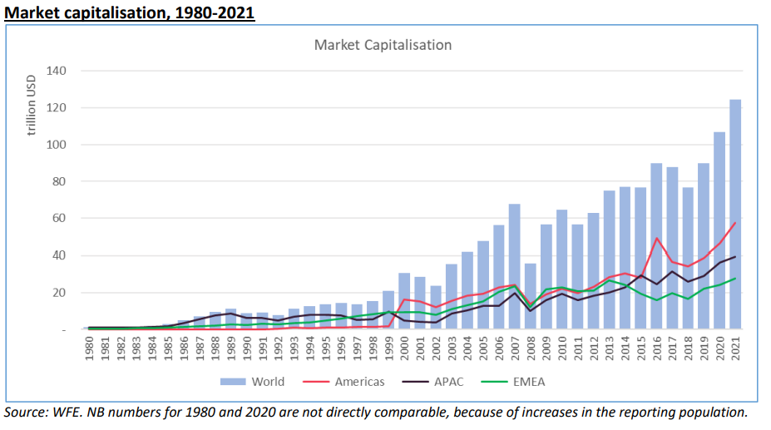
Growth in Market Capitalisation Worldwide
At the same time, participation has broadened well beyond traditional institutional investors. Advances in online brokerage platforms, retirement savings vehicles, and low-cost investment products have enabled millions of individual investors to enter the market. This widening base of participants has deepened liquidity, strengthened price discovery, and reinforced the central role of equity markets in wealth creation for households.
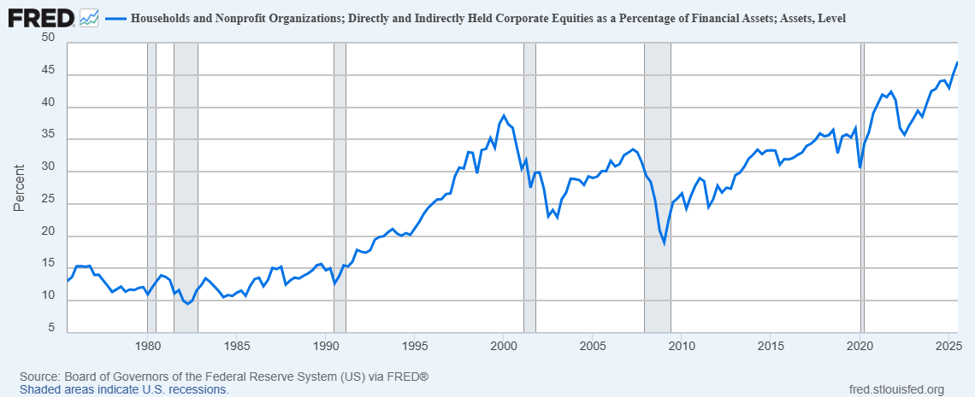
Growth in Household Investment in Equities in the US – 1975-2025
Alongside this growth in size and participation, the range and sophistication of equity market products have expanded significantly. Investors today can access a diverse array of instruments – from exchange-traded funds (ETFs) and index products to sector-specific and thematic strategies – that allow for more precise portfolio construction and risk management. This diversification has not only increased choice but has also made investing more efficient and accessible. By offering products tailored to different risk appetites and investment goals, equity markets have evolved to serve a broader spectrum of investors, supporting both innovation and long-term capital formation.
Over the past decade, values-based investing has grown significantly, with exchanges playing a key enabling role. As investor demand for sustainable and responsible investment opportunities has increased, exchanges have developed frameworks and products that support transparency and credibility in these markets. One example is the creation of green equity segments aligned with the World Federation of Exchanges’ Green Equity Principles, which help identify companies generating a substantial share of revenues from environmentally sustainable activities. These initiatives channel capital toward sustainable outcomes while preserving the integrity and investor protections of regulated markets.
In summary, companies are raising more capital through exchange markets enabling them to fund innovation, expand operations, and generate economic growth. At the same time, households can invest more easily than ever before generating wealth for ordinary people. For investors more broadly, today’s environment offers a wider range of asset classes, markets, and investment vehicles, making it possible to build more diversified portfolios and manage risk more effectively. Taken together, these developments strengthen the connection between savers and businesses, promote capital formation, and contribute to more dynamic and resilient economic growth.
The historical co-evolution of regulation, scale, and resilience implies that contemporary policy choices should prioritise innovations that strengthen trust and participation, rather than those that merely bypass existing safeguards. Policies that weaken governance in pursuit of speed or novelty risk undermine the very conditions that enabled markets to scale in the first place.
Innovation With a Purpose
Innovation in traditional financial markets is not a recent phenomenon. Since their inception, exchanges have been at the forefront of technological and structural change. In fact, the first stock exchange was an innovation in itself, created to enable the trading of shares of the first company that issued shares. These innovations have fundamentally reshaped how capital is raised, risk is managed, and markets operate and laid the foundations for the modern global financial system that drives economic growth and wealth creation.
One of the most significant milestones from the last fifty years was the transition from open outcry trading floors to electronic trading platforms. Exchanges invested heavily in computerised trading infrastructure that increased speed, transparency, and accessibility. Electronic order books replaced manual processes, enabling real-time price discovery, tighter spreads, and greater participation from a broader range of investors. This shift increased access to markets and established the technological backbone that supports today’s high-volume, globally interconnected trading environment.
Another transformative development was the dematerialisation of securities – the move from physical paper certificates to digital records. By replacing paper-based settlement with electronic registries and centralised depositories, markets dramatically reduced operational risk, settlement times, and administrative costs. This innovation improved market efficiency and security, paving the way for large-scale cross-border investment and the seamless functioning of modern custody and settlement systems.
Taken together, electronic trading and dematerialisation laid the groundwork for expanding trading hours. Derivatives exchanges were the first to offer round-the-clock trading in the 1990s – reflecting demand from global market participants. However, equity exchanges also began to offer extended trading hours in the form of pre-market and post-market trading. Currently, we are seeing several exchanges expanding their trading hours, including to round-the clock trading.
The rise of algorithmic and automated trading added another layer of innovation. Exchanges developed increasingly sophisticated matching engines and connectivity solutions to support faster execution and higher trading volumes. While often associated simply with speed, these advancements materially improved market liquidity and efficiency. At the same time, exchanges and market infrastructures invested in surveillance and control mechanisms to ensure orderly markets and maintain investor confidence.
Artificial Intelligence represents the latest phase of this evolution. Across industries, AI is enhancing productivity, and exchanges are no exception. Within exchange operations, AI is most widely deployed to strengthen market integrity through advanced fraud detection and market surveillance, and to support capital formation by streamlining listing processes and facilitating new product development. These applications reinforce trust while improving operational efficiency within regulated environments.
Reflecting these demands, information technology is typically one of the largest cost centres for exchanges. From matching engines and cybersecurity to data distribution and disaster recovery, nearly every core function relies on sophisticated IT infrastructure. As markets become ever-more electronic, global, and data-driven, exchanges continue to invest heavily in technology – underscoring their position as some of the most advanced and high-performance institutions in financial services.
These milestones illustrate a consistent pattern: established markets have continuously evolved through purposeful innovation. Each major advance has been a reflection of changing technologies, changing societies and changing demands by investors – innovation with a purpose. These foundational innovations underpin today’s markets and provide the platform on which current developments are built.
Crucially, these innovations emerged in tandem with the gradual development of formal regulatory and governance frameworks. Even where independent regulatory authorities had not yet taken their modern institutional form, exchanges operated under structured rulebooks and supervisory arrangements that embedded investor protection into market design. The co-evolution of innovation and oversight established an enduring principle of traditional markets: technological progress is pursued alongside accountability, transparency, and risk controls.
Historically successful innovations shared common characteristics: they reduced risk, broadened participation, improved transparency, or strengthened market integrity. Innovations that fail these tests – particularly those that fragment liquidity or weaken accountability – sit uneasily with the lessons of market evolution.
Tokenisation In Regulated Financial Markets
Tokenisation, alongside Distributed Ledger Technology (DLT), presents a more nuanced landscape. Despite being discussed for over 15 years, tokenisation has not yet gained substantial traction in established equities markets. As IOSCO recently highlighted, “public equities markets – especially in advanced economies – are already highly efficient, benefiting from decades of technology modernisation and proven intermediary chains.” Therefore, the marginal advantages gained through tokenisation have not yet met the tipping point at which the benefits outweigh the costs.
Furthermore, proponents of tokenisation often overstate the benefits. Benefits often attributed to tokenisation, such as 24/7 trading or fractional ownership, can be accomplished in established financial markets. In practice, “instantaneous” settlement can be delayed by up to ten minutes, which is material in markets that require deterministic timing for effective risk management. Furthermore, trading supported by a CCP, where multilateral netting is a very important for risk reduction and capital efficiency, is preferable in many cases to "instantaneous" settlement. Disintermediated models may create conflicts of interest that established regulatory frameworks seek to address, for example by requiring brokers to act in their clients’ best interests and by separating client representation from the operation of trading venues. Crucially, assertions that tokenisation drives investor “democratisation” overlook the extensive accessibility and participation enabled by regulated financial products.
Nevertheless, exchanges continue to see tokenisation as a natural evolution. Much like the shift from physical share certificates to dematerialised assets, tokenisation is likely the next step in this journey.
Rather than tokenising the trading layer, which remains best served by the already incredibly efficient matching engines our members run, our members are increasingly exploring benefits of tokenisation in the post-trade space. By focusing on the post-trade layer, tokenisation can improve existing financial infrastructure in three key areas.
Firstly, multi-party reconciliation is an area where tokenisation and DLT can deliver meaningful efficiency gains. Today’s post-trade environment often relies on multiple institutions maintaining separate records and reconciling them across systems, which introduces operational complexity, latency, and the potential for error. A shared, synchronised ledger can reduce the need for duplicative reconciliation by providing a common reference point for transaction data across participants. This does not eliminate the need for governance or controls, but it can streamline operational processes, lower operational risk, and improve data consistency across the market ecosystem.
Secondly, collateral mobility and intraday efficiency represent a particularly compelling use case. Tokenised collateral can, in principle, be transferred more quickly and with greater transparency across institutions and jurisdictions. Faster and more predictable collateral movement can enhance liquidity management, especially during periods of market stress when timely access to high-quality collateral is critical to maintaining orderly markets. By reducing frictions in collateral allocation and reuse, tokenisation has the potential to strengthen market resilience and support more efficient capital utilisation.
Finally, smarter automation through programmable assets and workflows offers opportunities to modernise post-trade operations. Embedding business logic into tokenised instruments can enable automated lifecycle events – such as corporate actions, margin calls, or settlement processes – to be executed according to predefined rules. This can reduce manual intervention, improve operational efficiency, and enhance transparency, while still operating within established legal and regulatory frameworks. Importantly, automation should be implemented in a way that preserves appropriate oversight and governance, ensuring that efficiency gains do not come at the expense of market integrity or risk management.
Debates around crypto and traditional markets are often framed in overly binary terms. We, as established financial market infrastructures, do a disservice to crypto if we vilify everything associated with crypto. Equally, crypto market players make a mistake if they ignore the collective learning garnered over centuries of established financial markets. While crypto markets have grown, parts of the ecosystem have been associated with a higher prevalence of practices that raise market integrity and investor protection concerns than is typically observed in established markets.
The critical distinction lies in governance and oversight. Established markets operate within mature regulatory frameworks and exchange supervision designed to detect, deter, and address misconduct. By contrast, gaps in regulation and governance in some areas of the crypto ecosystem can weaken safeguards, often reflecting an underappreciation of the purpose and value of long-standing market protections.
This is precisely why our members are pursuing tokenisation within established regulatory frameworks. The accumulated wisdom of the industry and regulators – born of deep experience – ensures that safeguards, transparency, and integrity remain at the forefront. While we do not adopt an antagonistic stance toward crypto markets, it is important to acknowledge that some touted innovations in crypto discard hard-earned lessons from the rules-based financial system. When protections are absent, the risks of speculation or catastrophic failures – such as those witnessed in crises like FTX – become glaring. Thus, the path forward is to integrate innovative technologies thoughtfully, preserving the resilience that mature market regulation has long ensured.
In summary, tokenisation will succeed when it upgrades the current market plumbing without downgrading trust. It is our current view not that all layers of the market should be equally disrupted, but that innovation should be channelled toward areas where frictions persist – such as reconciliation, collateral mobility, and operational risk – while core price-formation mechanisms remain anchored in proven market structures.
Conclusion
The history of modern equity markets demonstrates that innovation and investor protection are not competing objectives, but mutually reinforcing forces. Over the past 50 years, exchanges and regulators have overseen a period of extraordinary expansion in market scale, participation, and technological sophistication. This growth did not occur despite regulation; it occurred alongside and, in many respects, because of it. Robust governance frameworks helped foster the trust necessary for broader participation, deeper liquidity, and sustained capital formation.
Viewing innovation as institutional rather than purely technological reframes the policy question. The relevant issue is not whether a technology is novel, but whether it can be governed, supervised, and integrated into existing accountability structures. Innovations that cannot be credibly overseen will struggle to scale sustainably, regardless of their technical sophistication.
The evidence presented in this paper illustrates a consistent pattern. From the transition to electronic trading and the dematerialisation of securities, to the rise of advanced market infrastructure and the adoption of artificial intelligence, exchanges have repeatedly embraced innovation within structured regulatory environments. These innovations improved efficiency, transparency, and accessibility while embedding safeguards that protect investors and maintain orderly markets. The result has been markets that are not only faster and more technologically advanced, but also more inclusive and resilient.
Current debates around tokenisation and DLT should be viewed through this historical lens. The evidence does not support regulatory neutrality between models that preserve market integrity and those that discard it. History consistently favours innovation that operates within credible governance frameworks. Where contemporary innovators diverge from these lessons, familiar risks re-emerge: fragmented liquidity, conflicted intermediaries, weakened investor protections, and loss of trust. These are not theoretical concerns, but recurring features of past market failures.
Tokenisation offers meaningful opportunities when it strengthens post-trade efficiency without eroding established protections. Its long-term success depends on integrating it within established frameworks of accountability, governance, and investor protection. Experience shows that sustainable innovation flourishes where trust is preserved and where market participants operate within clear and credible rules.
Framing the future of finance as a choice between innovation and protection is therefore a false dichotomy. Well-designed regulation does not inhibit progress; it provides the foundation on which innovation can scale safely and deliver broad economic benefits. Exchanges, as technology-driven institutions operating at the centre of capital markets, are uniquely positioned to bridge new technological possibilities with the accumulated wisdom of established market structures.
The central lesson is clear: innovation that weakens trust may move quickly, but innovation that strengthens institutions is what endures.

Background

Established in 1961, the WFE is the global industry association for exchanges and clearing houses.
Headquartered in London, it represents the providers of over 250 pieces of market infrastructure,
including standalone CCPs that are not part of exchange groups. Of our members, 36% are in Asia Pacific, 43% in EMEA and 21% in the Americas. The WFE’s 87 member CCPs and clearing services
collectively ensure that risk takers post some $1.3 trillion (equivalent) of resources to back their
positions, in the form of initial margin and default fund requirements. The exchanges covered by WFE data are home to over 55,000 listed companies, and the market capitalization of these entities is over $111tr; around $124tr in trading annually passes through WFE members (at end-2023).

The WFE is the definitive source for exchange-traded statistics and publishes over 350 market data
indicators. Its free statistics database stretches back more than 40 years and provides information and insight into developments on global exchanges. The WFE works with standard-setters, policy makers, regulators and government organisations around the world to support and promote the development of fair, transparent, stable and efficient markets. The WFE shares regulatory authorities’ goals of ensuring the safety and soundness of the global financial system.

With extensive experience of developing and enforcing high standards of conduct, the WFE and its
members support an orderly, secure, fair and transparent environment for investors; for companies
that raise capital; and for all who deal with financial risk. We seek outcomes that maximise the
common good, consumer confidence and economic growth. And we engage with policy makers and
regulators in an open, collaborative way, reflecting the central, public role that exchanges and CCPs
play in a globally integrated financial system.

Website: www.world-exchanges.org
Twitter: @TheWFE
If you have any further questions, or wish to follow-up on our contribution, the WFE remains at your disposal. Please contact:
James Auliffe, Senior Manager, Regulatory Affairs: jauliffe@world-exchanges.org
Richard Metcalfe, Head of Regulatory Affairs: rmetcalfe@world-exchanges.org
or
Nandini Sukumar, Chief Executive Officer: nsukumar@world-exchanges.org.

Taken from WFE’s Financing the Future, 2023: https://www.world-exchanges.org/our-work/articles/financing-the-future
Taken from Board of Governors of the Federal Reserve System (US) https://fred.stlouisfed.org/series/BOGZ1FL153064486Q#
WFE’s Green Equity Principles, 2023: https://www.world-exchanges.org/news/articles/wfe-publishes-green-equity-principles-industry-seeks-counter-greenwashing-and-aid-capital-flows
https://www.beursgeschiedenis.nl/en/the-story/
https://www.world-exchanges.org/our-work/articles/policy-and-market-impacts-extended-trading
https://www.iosco.org/library/pubdocs/pdf/IOSCOPD809.pdf
WFE’s Demystifying Tokenisation: Embracing the Future, 2024: https://www.world-exchanges.org/our-work/articles/demystifying-tokenisation-embracing-future
WFE Research Working Paper: The effect of DLT settlement latency on market liquidity: https://www.world-exchanges.org/our-work/articles/effect-dlt-settlement-latency-market-quality

